
Invitation
You are cordially invited to the
Manna Society’s Annual General Meeting
7.00pm Wednesday 28th September 2016
At The Manna Centre.
The Manna Centre’s entrance is:
The gateway between
60 & 62 Weston Street
London SE1 3QJ
(Directly opposite the Greenwood Theatre entrance)
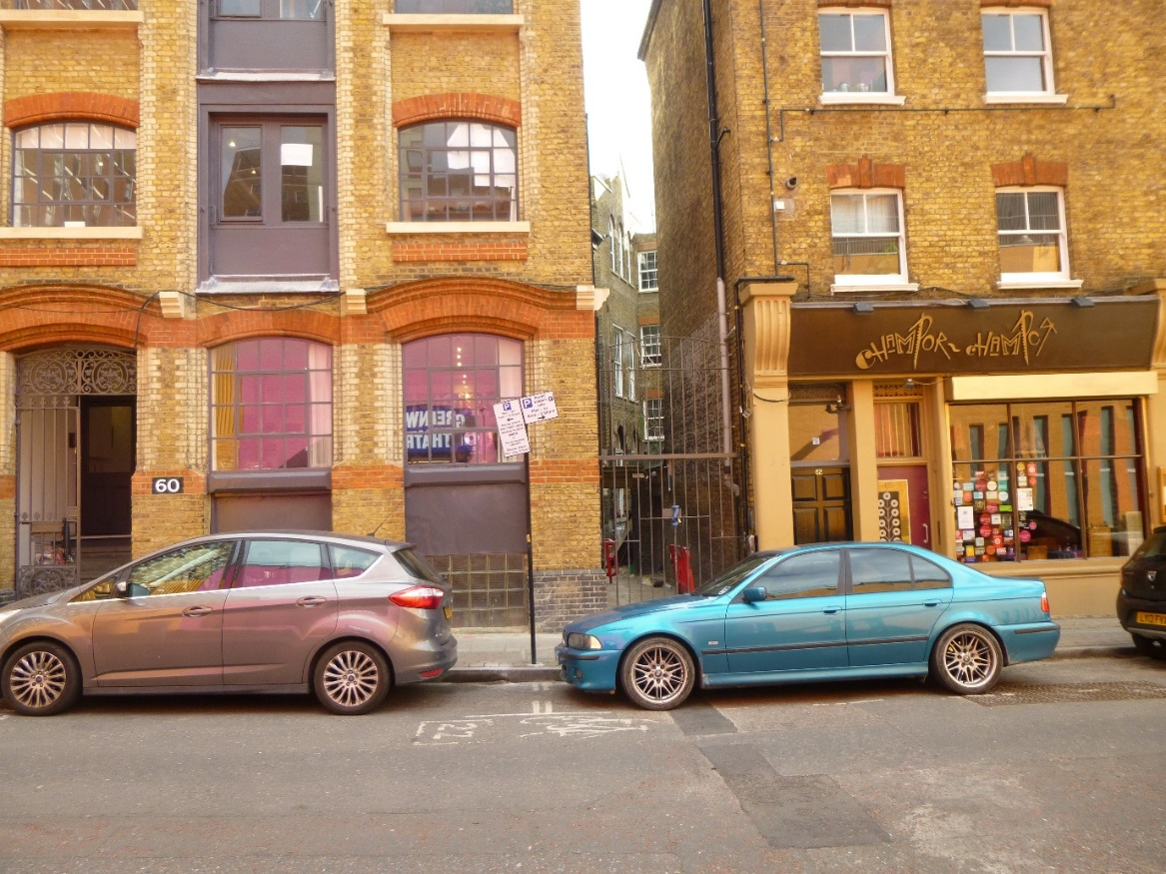
Entrance
↓

